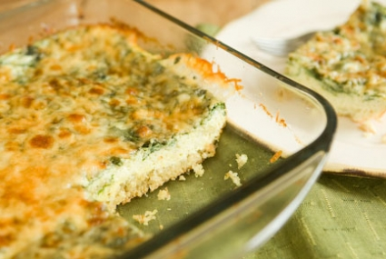
Quinoa Egg Bake with Thyme and Garlic

Serves: 6

The quinoa in this recipe gets baked in the oven so it doesn't need to be precooked. Instead, it settles into the bottom of the pan and creates a moist crust. Quinoa is a super grain—it contains all 8 essential amino acids—making it a complete protein.

Ingredients:
1 teaspoon butter
1/2 cup uncooked quinoa
8 eggs
1 1/4 cup milk
1 tablespoon chopped garlic
1 teaspoon chopped thyme
1/2 teaspoon salt
1/2 teaspoon pepper
2 cups packed baby spinach, roughly chopped
1 cup finely shredded Romano or Parmesan cheese

Method:
Preheat oven to 350°F. Grease an 8-inch x 8-inch glass or metal baking dish with butter; set aside.
Put quinoa into a fine mesh strainer and rinse until cold running water until water runs clear; drain well.
In a large bowl, whisk together eggs, milk, garlic, thyme, salt, pepper and quinoa. Stir in spinach then pour mixture into prepared dish. Cover tightly with foil then jiggle dish gently from side to side so that quinoa settles on the bottom in an even layer. Bake until just set, about 45 minutes. Remove foil and sprinkle top evenly with cheese. Return to oven and bake, uncovered, until golden brown and crisp, 10 to 15 minutes more. Set aside to let cool briefly, then slice and serve.

